**Lesson20 Azure Durable Function**

**Notes: -**

**1-Azure Durable function is stateless which means send request and response returned**

**2-if you have multiple function that each one execute after another and send parameter to the second function as below**

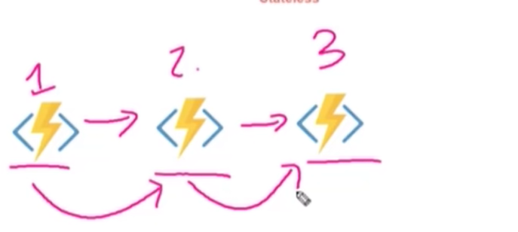

**3-or you have function that call 2 function in syncheses way at the same time**

**(you have to check each function return result state and the data returned manually)**

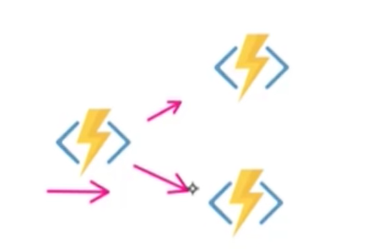

**Durable Function Component**

**Durable function has 3 main parts**

**1-trigger function: which used to call via http request**

**2-trigger orchestrator: which responsible to manage the trigger activity and manage the result state and call the next activity after previous activity function is called**

**(so when call fun01 is called via trigger function that send to orchestrator that call activity function 01 to finish executing then after finish the result returned from activity function01 to orchestrator function to activity function02 and do the same thing)**

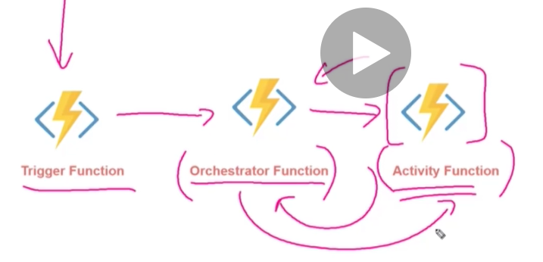

**Example: -**

**1-in azure portal > function > add Durable function HTTP starter**

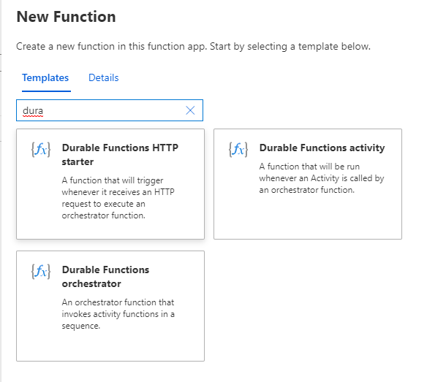

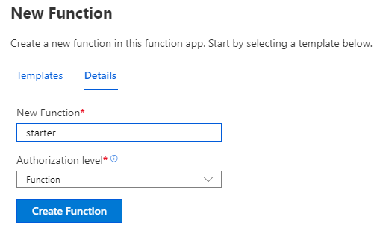

**We see in the below section default code**

**#r "Microsoft.Azure.WebJobs.Extensions.DurableTask"**

**#r "Newtonsoft.Json"**

**using System.Net;**

**public static async Task<HttpResponseMessage> Run(**

**HttpRequestMessage req,DurableOrchestrationClient starter,string functionName,ILogger log){**

**// Function input comes from the request content.**

**dynamic eventData = await req.Content.ReadAsAsync<object>();**

**// Pass the function name as part of the route**

**string instanceId = await starter.StartNewAsync(functionName, eventData);**

**log.LogInformation($"Started orchestration with ID = '{instanceId}'.");**

**return starter.CreateCheckStatusResponse(req, instanceId);}**

**2-on Azure Portal > function > Durable function**

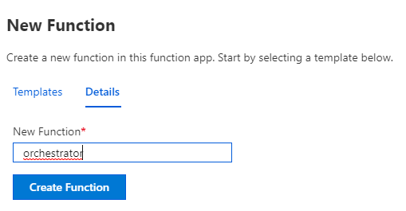

**(we see on the default function that it called activity function as below)**

**(we see that it called activity function called ActivityTest 3 times)**

**#r "Microsoft.Azure.WebJobs.Extensions.DurableTask"**

**public static async Task<List<string>> Run(DurableOrchestrationContext context){**

**var outputs = new List<string>();**

**// Replace "Hello" with the name of your Durable Activity Function.**

**outputs.Add(await context.CallActivityAsync<string>("ActivityTest", "Tokyo"));**

**outputs.Add(await context.CallActivityAsync<string>("ActivityTest", "Seattle"));**

**outputs.Add(await context.CallActivityAsync<string>("ActivityTest", "London"));**

**// returns ["Hello Tokyo!", "Hello Seattle!", "Hello London!"]**

**return outputs;}**

**3-on Azure Portal > function > Activity function called ActivityTest**

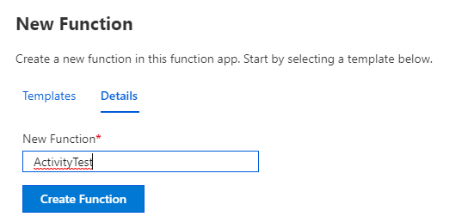

**(on the code + Test we see the sample code as below to return result)**

**#r "Microsoft.Azure.WebJobs.Extensions.DurableTask"**

**public static string Run(string name)**

**{ return $"Hello {name}!";}**

**4-on the Postman we copy the URL of the starter azure function as below**

**https://enbehfunc.azurewebsites.net/api/orchestrators/orchestrator?code=M7y91H4gXeDRIZTH2kLnqv5egEati0q9WUoYnh2ETkJzwYx4fzISBw==**

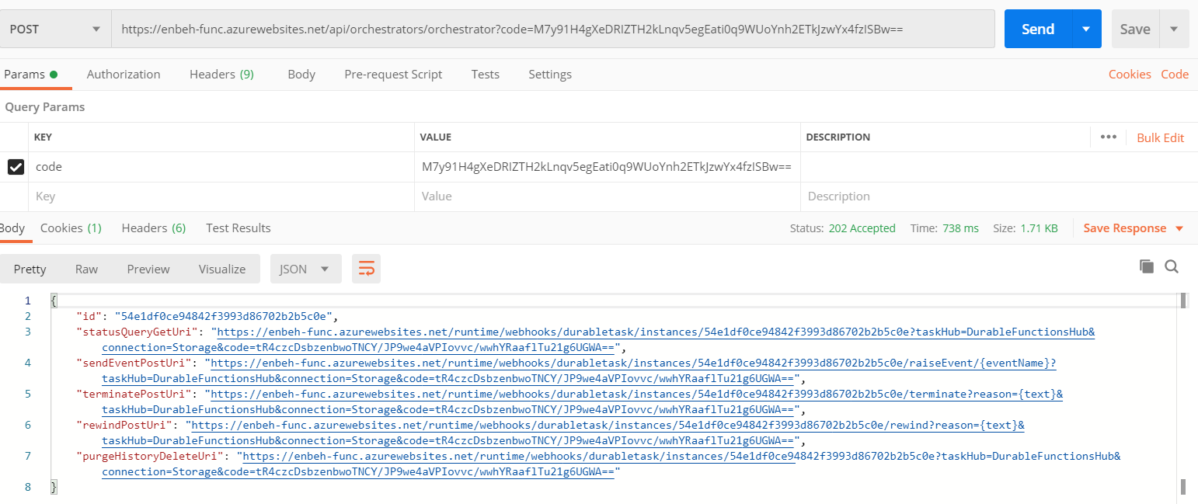

**(we get the statusQueryGetURL which means that the URL generated by starter function by specify the Orchestrator function)**

**2-we copy the statusQueryGetURL and trigger the API request and result will be**

**(it call the activity function three times as below)**

**https://enbehfunc.azurewebsites.net/runtime/webhooks/durabletask/instances/54e1df0ce94842f3993d86702b2b5c0e?taskHub=DurableFunctionsHub&connection=Storage&code=tR4czcDsbzenbwoTNCY/JP9we4aVPIovvc/wwhYRaaflTu21g6UGWA==**

